Newark
Scottish Country Dance Society

Walkthrough
Evening Social

Saturday 14th February 2026
6.00pm – 9.00pm
Bridge Community Centre
Newark NG24 2DQ
Tickets on the door £10.00 Spectators £5.00
Raffle
Please bring own mug and bring and share supper for the interval.

Pelorus Jack | 8x32J
The Swan and the Tay | 3x32S
Maxwell’s Rant | 8x32R
Lamb Skinnet | 8x32J
Far North Queensland | 5x32S
The Falls of Rogie | 8x32R
Neil M Grant | 8x32J
MacDonald of Keppoch  The Deil Amang the Tailors | 2x32S/2x32R  8x32R
----INTERVAL----
The Yorkshire Rose | 8x32J
The Glengarry Homestead | 4x32S
The Rutland Reel | 8x40R
Ian Powrie’s Farewell to Auchterarder | 1x128J
Midsummer Common | 8x32S
Scott Meikle | 4x32R
Bow Fiddle Rock | 8x32J
MacDonald of the Isles | 3x32S
The Highland Rambler | 8x40R

Dance List: https://my.strathspey.org/dd/list/64234/

Dances will be walked through once, for the benefit of dancers who may
be attending a Social Dance for the first time.

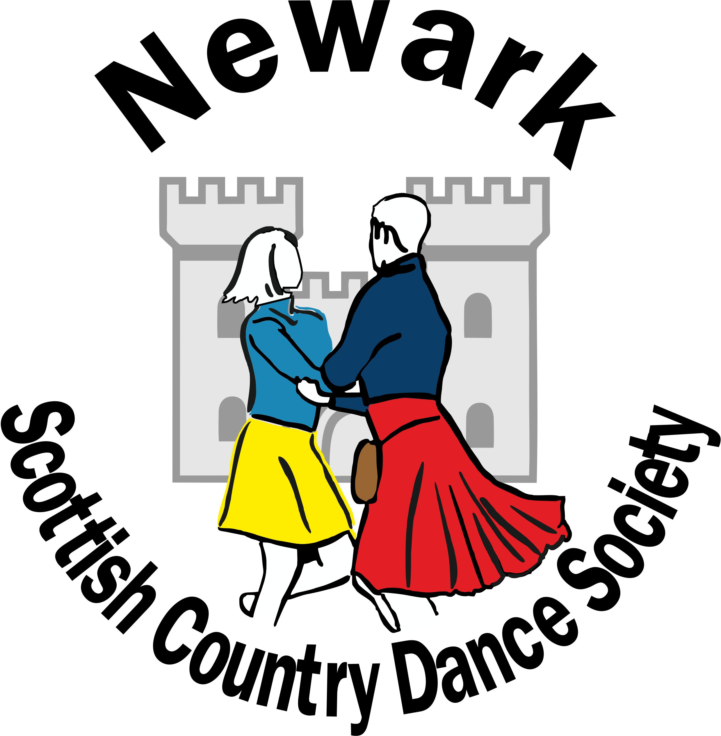
www.newarkscottishdancing.weebly.com

Day School

Saturday 14th February 2026

Bridge Community Centre
Lincoln Road
Newark NG24 2DQ

Teacher: Zsofia Jozsef

Musician: Iain Carmichael

For reservations contact
financenscds@hotmail.com
07475 516558
For dancing information contact
Pat Harland 07752 283119

Application Form
-----------------------------------------------------------------------------------------------------------------------------------------

Surname ………………………………….
First name (for name badge) …….…….
Address …………………………………..
……………………………………………..
……………………………………………..
Postcode …………. Phone …...………
Email ……………………………………..
Please tick requirements: Please print email.
 | Cost | Required
Morning Session | £8.00
Afternoon Session | £8.00
Lunch | £8.00
Lunch (Vegetarian) | £8.00
Total Payment
As all our food is prepared by volunteers, we cannot guarantee any ‘FREE FROMS’,
though we will do our best to accommodate your wishes. If this is a major issue, we
suggest that you bring your own lunch.
Payments by Bank Transfer (BACS or Faster Payment)
Lloyds Bank, Account Name: Newark SCDS
Sort Code: 30-98-97, Account Number: 64673568
Using your name and DY SCH as reference.
Or Cheque - payable to Newark SCDS, or Cash.
Send your completed form to:
Heather McElhoney
15 Steeple Leas, Grantham, Lincolnshire NG31 8FL
Tel: 07475 516558
Email:financenscds@hotmail.com
Applications will be dealt with as they are received as there will be a limit on numbers. A waiting list will be implemented if necessary. Your application will be acknowledged.
Deadline for receipt of applications: 31st December 2025
I understand that Newark Scottish Country Dance Society accepts no liability for loss or injury in connection with this event.

Signed ……………………………. Date …………….

Please use a separate form for each application- photocopies acceptable.

Newark Scottish Country
Dance Society

Day School
Saturday 14th February 2026

10.00 - 10.30 | Registration and coffee
10.30 - 12.30 | Fundamentals of Scottish Country Dancing
12.30 - 14.00 | Lunch
14.00 - 17.00 | Experienced/Advanced dancers  There will a 20 minute break for tea/coffee

Teacher: Zsofia Jozsef

Musician: Iain Carmichael

Location: Bridge Community Centre
Lincoln Road
Newark NG24 2DQ

The morning session is for dancers who aim to improve their steps, dance technique and gain confidence in dancing basic formations.

The afternoon session is for more experienced dancers who can confidently dance the main formations, including reels, poussettes and hello-goodbye setting. This knowledge will be assumed so the teacher can concentrate on developing further skills. Several of the figures taught will be drawn from the evening social dance programme.

It is expected that all participants will wear footwear appropriate for Scottish country dancing, such as ghillies.

